# **Name: Abdur R. Qureshi**

# **Roll No: 242466**

Practical No: 9

Date Of Performance: 25/09/2025

Aim: Implementation of React useState, useEffect, useContext

Q) Create functional components to demonstrate useState

CODE (Nose):

"use client"

import { useState } from "react"

export const Nose = () => {

    const [count, setCount] = useState(271000)

    const increment = () => {

        setCount(count + 1)

    }

    const decrement = () => {

        if (count < 271001) {

            alert("You can't go below the actual number of Jews killed in the holocaust.")

        }

        else {

            setCount(count - 1)

        }

    }

    return (

        <section className="h-screen flex flex-col items-center justify-center gap-4">

            <h2 className="text-2xl font-bold">How many Jews were killed in the holocaust?</h2>

            <div className="flex items-center gap-4">

                <button

                    onClick={decrement}

                    className="px-4 py-2 bg-red-500 text-2xl text-white rounded-full hover:bg-red-600"

                >

                    -

                </button>

                <span className="text-2xl font-bold">{count}</span>

                <button

                    onClick={increment}

                    className="px-4 py-2 bg-green-500 text-2xl text-white rounded-full hover:bg-green-600"

                >

                    +

                </button>

            </div>

        </section>

    )

}

CODE (Rendering):

import { Nose } from "./components/Nose";

export default function Home() {

  return (

    <>

      <Nose />

    </>

  );

}

OUTPUT:

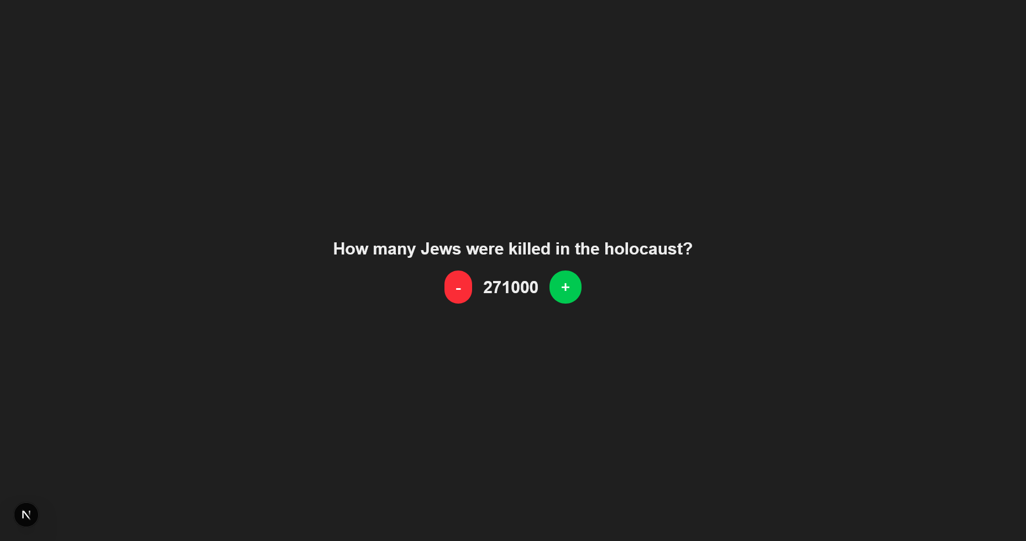Initial

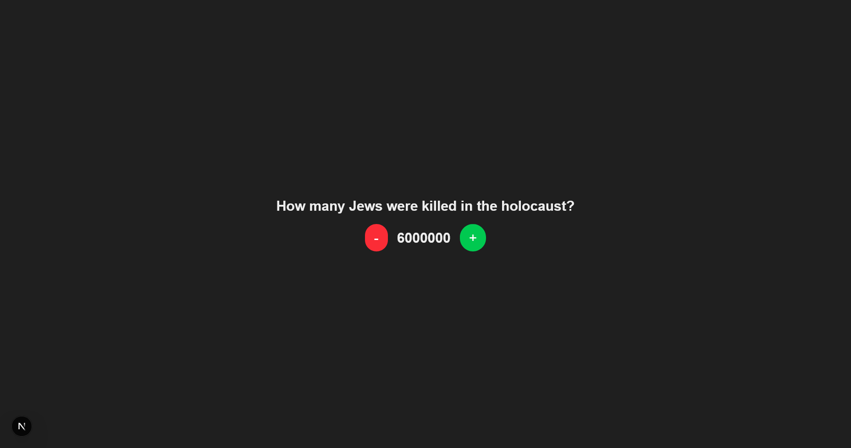

Incremented Value (Propaganda)

Q) Create functional components to demonstrate useEffect

CODE (HeilHitler):

"use client"

import { useEffect, useState } from "react"

export const HeilHitler = () => {

    const [count, setCount] = useState(271000)

    const increment = () => {

        setCount(count + 1)

    }

    const decrement = () => {

        if (count < 271001) {

            alert("You can't go below the actual number of Jews killed in the holocaust.")

        }

        else {

            setCount(count - 1)

        }

    }

    useEffect(() => {

        console.log("Heil Hitler Counter: ", count);

    }, [count])

    return (

        <section className="h-screen flex flex-col items-center justify-center gap-4">

            <h2 className="text-2xl font-bold">How many Jews were killed in the holocaust?</h2>

            <div className="flex items-center gap-4">

                <button

                    onClick={decrement}

                    className="px-4 py-2 bg-red-500 text-2xl text-white rounded-full hover:bg-red-600"

                >

                    -

                </button>

                <span className="text-2xl font-bold">{count}</span>

                <button

                    onClick={increment}

                    className="px-4 py-2 bg-green-500 text-2xl text-white rounded-full hover:bg-green-600"

                >

                    +

                </button>

            </div>

            <p>Check Console</p>

        </section>

    )

}

CODE (Rendering):

import {HeilHitler} from "./components/HeilHitler";

export default function Home() {

  return (

    <>

      <HeilHitler/>

    </>

  );

}

OUTPUT:



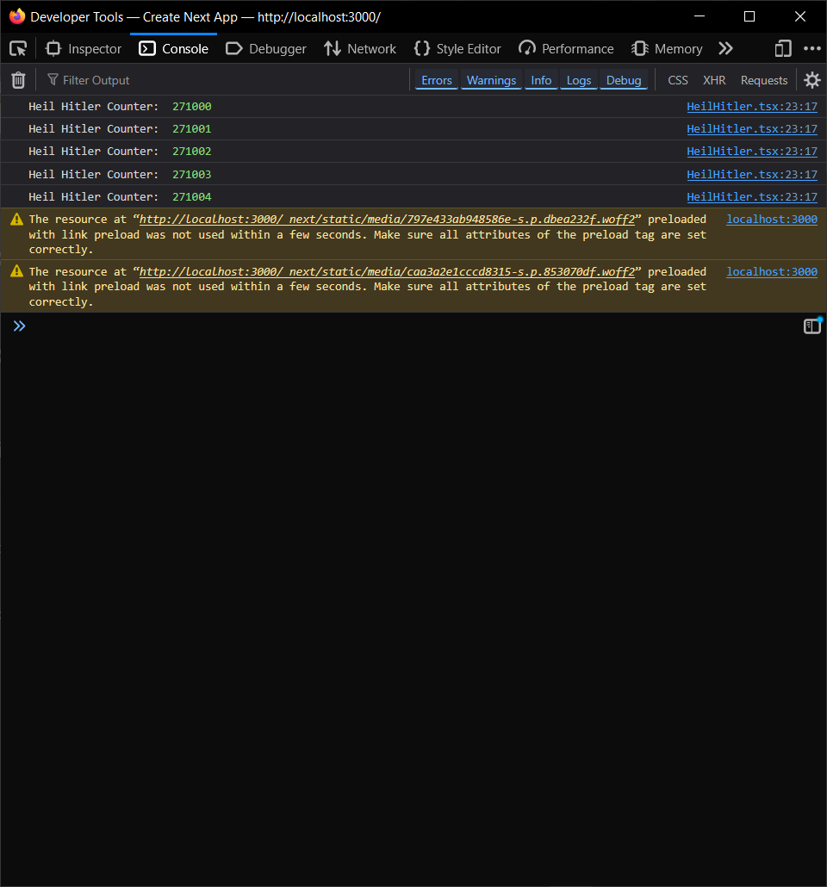

Console

Q) Create functional components to demonstrate useContext

CODE (Animals):

"use client"

import { useState, createContext, useContext } from "react"

const CounterContext = createContext({

    count: 271000,

    increment: () => { },

    decrement: () => { }

})

const CounterProvider = ({ children }: { children: React.ReactNode }) => {

    const [count, setCount] = useState(271000)

    const increment = () => setCount(count + 1)

    const decrement = () => {

        if (count <= 271000) {

            alert("You can't go below the actual number of Jews killed in the holocaust.")

        } else {

            setCount(count - 1)

        }

    }

    return (

        <CounterContext.Provider value={{ count, increment, decrement }}>

            {children}

        </CounterContext.Provider>

    )

}

const useCounter = () => useContext(CounterContext)

export const Counter = () => {

    const { count, increment, decrement } = useCounter()

    return (

        <section className="h-screen flex flex-col items-center justify-center gap-4">

            <h2 className="text-2xl font-bold">Gassed Jews Counter</h2>

            <div className="flex items-center gap-4">

                <button onClick={decrement} className="px-4 py-2 bg-red-500 text-white rounded-full">

                    -

                </button>

                <span className="text-2xl font-bold">{count}</span>

                <button onClick={increment} className="px-4 py-2 bg-green-500 text-white rounded-full">

                    +

                </button>

            </div>

        </section>

    )

}

export const HolocaustCounter = () => (

    <CounterProvider>

        <Counter />

    </CounterProvider>

)

CODE (Rendering):

import HolocaustCounter from "./components/HolocaustCounter";

export default function Home() {

  return (

    <>

      <HolocaustCounter/>

    </>

  );

}

OUTPUT:



